Network reconnaissance, port scanning
Network layout example
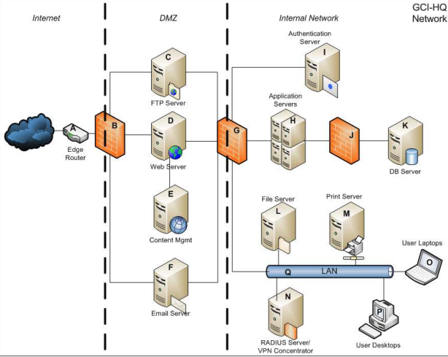
Network scanning positions
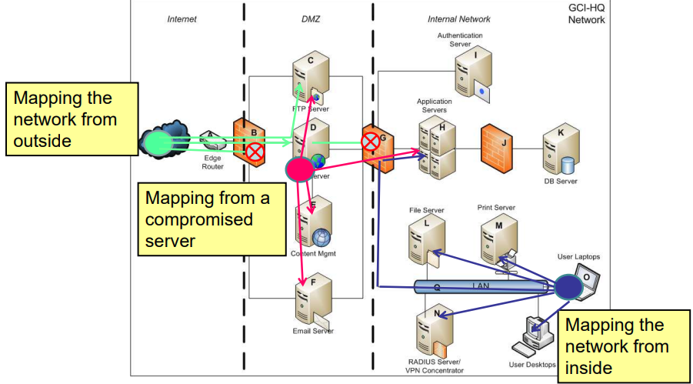
Circuit switched vs packet switched networks
- In circuit switched networks a virtual line is allocated between the communicating parties. The line is busy until the communication ends
- In packet switched networks the caller sends packets to the direction of the receiver. There’s no planned route, each network device chooses the most appropriate device as next considering routing tables and traffic

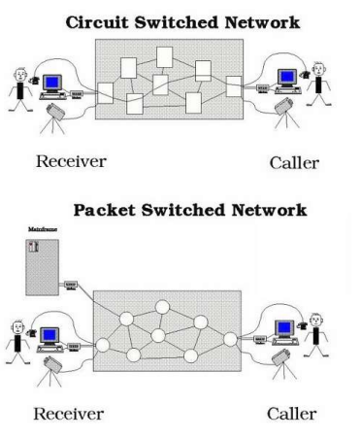

Packet switched networks – avoiding infinite loops
- As there’s no planned route between the sender and the receiver it can happen that a packet gets stuck in the network following an infinite loop
- Messages are placed in network packets according to the OSI model
- Every packet should contain a TTL value Time To Live) that is decreasing when arriving to the next network device (network hop)
- When TTL is 1 the packet has to be dropped
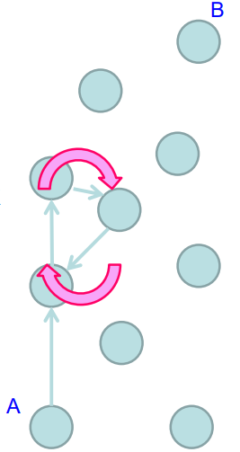

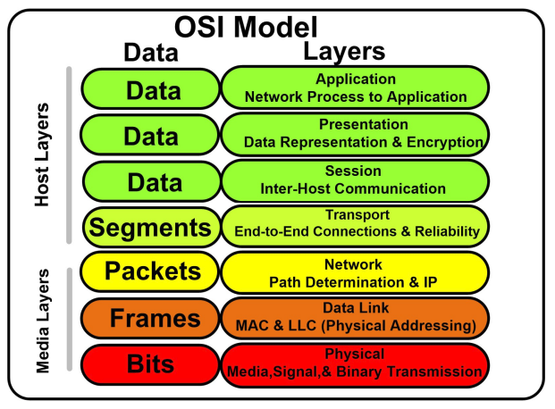
The OSI model
Layer 3 – Internet Control message protocol (ICMP)
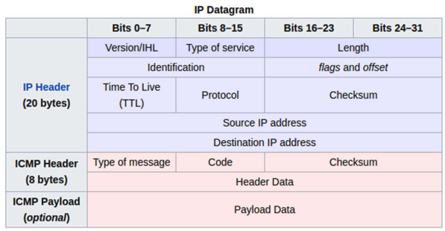
- To check if a host is responding
- Echo request – Echo reply to make sure a host is turned on

Network mapping – answer options
Positive answer
- In case of ICMP we get an echo reply for our echo request
Negative answer
- In case of ICMP we get destination unreachable / host unreachable message
No answer
- In case of ICMP, we have no response from the host that was addressed by the echo request

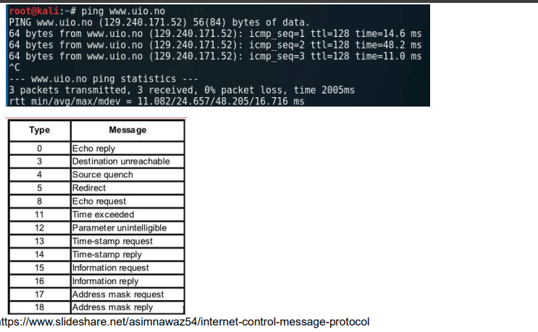
Internet Control Message Protocol (ICMP) example – ping

Since ICMP contains the TTL value, it is possible to guess the receiver host’s operating system by its TTL
Initial TTL values:
- Windows: 128 since Windows2000
- Linux: 64 for 2.0.x kernel
- Solaris: 255

Internet Control Message Protocol (ICMP) examples – traceroute
Since all devices have to drop the packets with ttl=1, it is possible to map the route of a packet by repeating the ping with increasing ttl values
First, the initial ttl is 2, so after the first hop the device sends a time exceeded message
With ttl=3 the time exceed message is coming from the device at the second hop etc
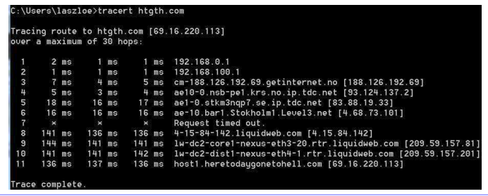

Internet Control Message Protocol (ICMP) examples – visual traceroute
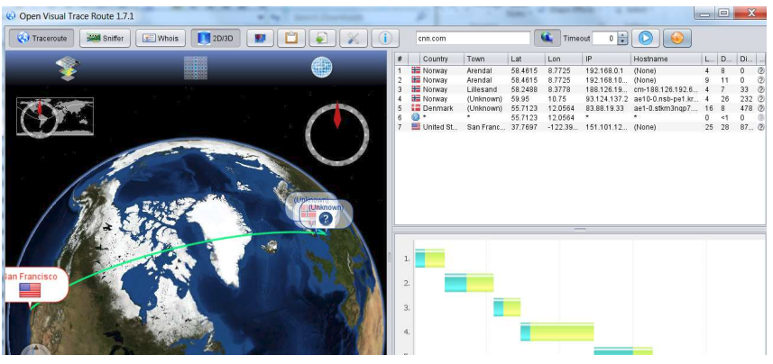
Nmap basic usage
Nmap is an universal port scanner
It is able to carry out ordinary and specific host service discoveries
Nmap has a scripting engine which makes it capable of carrying out complex scanning as well as vulnerability discovery, fuzzing, etc tasks
For one simple ping the following command has to be used:
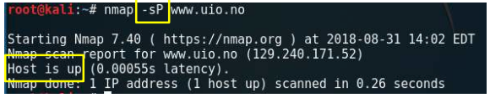
Host(s) to be scanned can be set in multiple ways:
With domain: www.uio.no
With ip: 129.240.171.52
With ip range (CIDR): 129.240.171.0/24
With ip range (from-to) 129.240.171.2-6, 129.240.170-175.1
With list: 129.240.171.1, 129.240.171.2

The main parameter is the scanning type that can be set with the -s switch, e.g -sP: ping scanning
Example task: How many hosts are alive in our current local network range? E.g nmap -sP 192.168.0.0/24

With nmap it can be set:
- Type of scan
- Additional tests (e.g version detection)
- Timing option (how many tries, how many parallel requests, max retries, scan delay, etc)
- Hosts / host input
- Output result format (flat file, xml, etc)
- Filtering (e.g show only open ports)
- Scripts to run

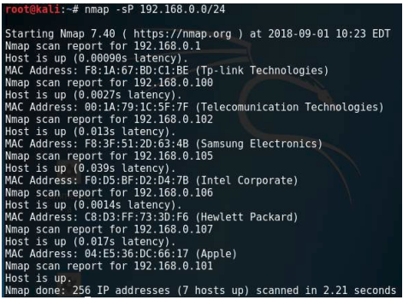
Nmap - ping scan
- With the –sP switch
- Nmap pings all the specified hosts
- The available hosts are listed with their MAC address
- ICMP messages are not always allowed in a network

Nmap - List scan
With the –sL switch
Has no connection with the hosts
The DNS server is asked if a specific domain is registered in its database
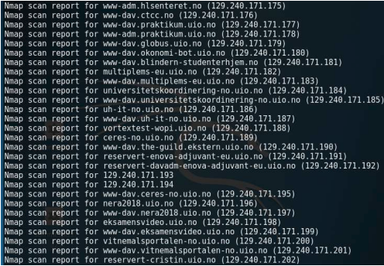

Layer 4 – Data transmission
Apart from sending short simple messages, bigger datablocks can be transmitted between the hosts. The datatransfer is carried out in the 4th layer by using 2 differentapproaches:
- UDP: streaming the data (no guarantee that all data willarrive, but fast)
- TCP: the arrival of all data is guaranteed in the rightorder (trustworthy transmission, slower than UDP)
In addition, the data transmission is carried out using portnumbers. One host can send and receive data in multiplechannels using different port numbers for different services.

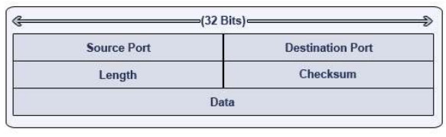
Layer 4 – UDP protocol

The port number is a 2-byte value, it can be between 0-65535(=2³²)
Typical UDP ports with services:
- UDP 53 DNS
- UDP 111 RPC (Remote Procedure Call)
- UDP 123 NTP (Network Time Protocol)

Layer 4 – TCP protocol
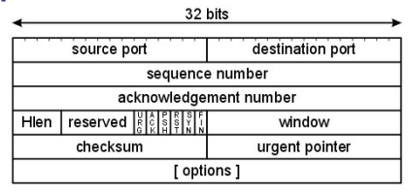

In order to ensure that the packages arrived in the right order the sequence number and the acknowledgement number are used.
TCP flags are for maintaining the connection status (urg,ack, psh, rst, syn, fin).

Layer 4 – TCP typical services
- TCP 80: web http
- TCP 443: web https
- TCP 20,21: ftp
- TCP 22: ssh
- TCP 25: smtp
- TCP 137,139,445: netbios
- TCP 3306: mysql
- TCP 3389: remote desktop
- TCP 5900: VNC
Remember that any service can be used in any port, these are only recommendations

Layer 4 – TCP 3-way handshake
TCP handshake is the process when a connection is about to be established in a specific port.
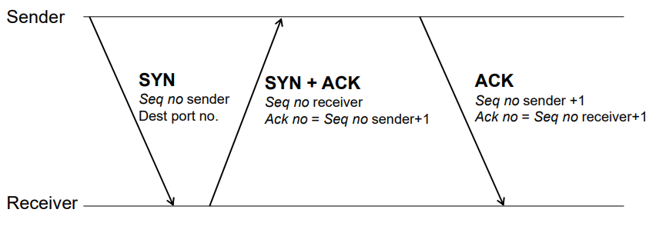

Tcp scan (full tcp scan)
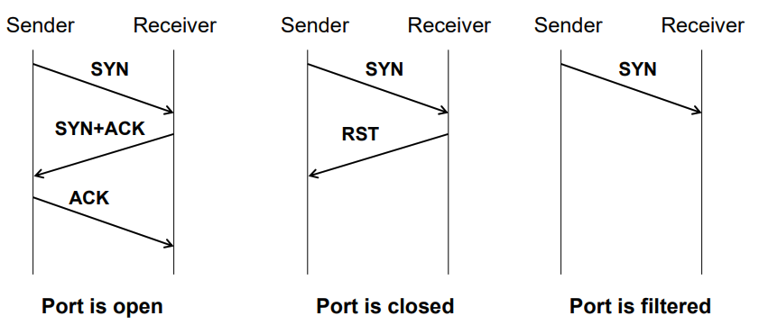
Nmap carries out tcp scan with the –sT switch Port numbers can be specified optionally Example: nmap –sT –p80,43 host

Tcp scan (full tcp scan)
The number of possible ports is 65535, scanning all ports requires too much time (and too noisy). We can reduce the port numbers by specifying them with the –p switch. Without –p nmap will scan the 1024 most popular ports.
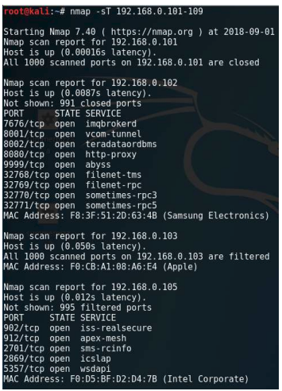

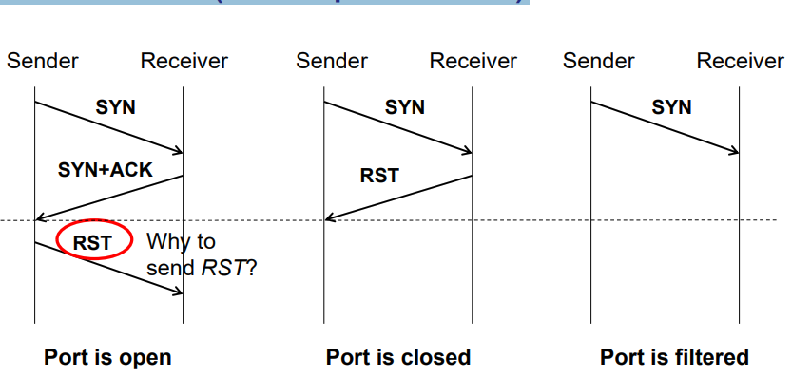
SYN scan (half open scan)
Nmap carries out syn scan with the –sS switch. Port numbers can be specified optionally. Example: nmap –sS –p80,43 host

Why use syn scan instead of tcp scan? Does it have different result? The main difference is that in case of tcp scan the tcp connection is established for every open ports. Firewalls usually log only the established connections.
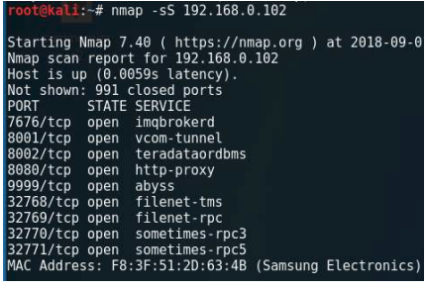

Reverse scans
In case of reverse scanning, Nmap looks for closed ports. The result of a reverse scan can be either open/filtered or closed. It cannot be determined if a port is filtered or open. According to TCP if a port is closed the receiver sends rst answer no matter which status flag is set:
- sN Null scan (no flags)
- sF Fin scan (only fin flag is set)
- sX Xmas scan (push, fin and rst flags are set)
- sM Maimon scan (fin and ack are set)
With hping we can set any flag (more reverse scan options, see later)

Ack scan
Ack scan is to determine if a firewall is stateful or stateless.
- The stateless firewall examines a packet as it is independent of the previous packets.
- The stateful firewall can follow packet streams considering previous packets.
For a stateless firewall an ack package seems like the third step of the handshake. For the stateful firewall it is pointless (no syn and syn+ack before). nmap -sA

Decoy scan – hide ourselves
If a TCP connection is established it will be logged by the firewalls – this is noisy (in a network with huge internet traffic there are several port scans by robots).
Decoy scan uses the «needle in the haystack» theory: it sends out each request in multiple copies with different source ip.
Questions: Can we modify our source ip in the packet?If so, why don’t we modify it all the time?
Decoy scan example: nmap –sT –p80 –D5.44.65.150,195.88.55.16, 194.61.183.124 www.uio.no

Idle scan, ftp bounce – hide ourselves
There are more sophisticated ways of hiding ourselves:
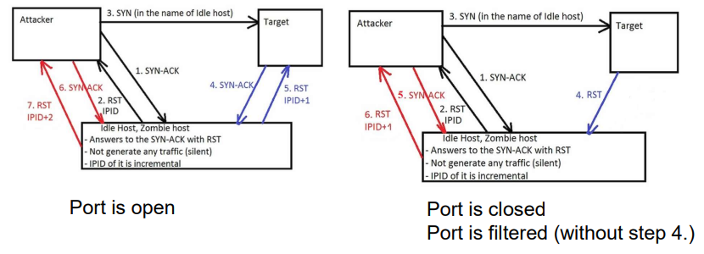
Example idle scan: nmap –sI zombie.somewhere.com www.uio.noExample ftp bounce: nmap -b user@FTP-Address Target-Address

Operating System detection
Nmap’s remote OS detection uses TCP/IP stack fingerprinting. Nmap sends a series of TCP and UDP packets to the remote host and examines practically every bit in the responses.
After performing dozens of tests such as TCP ISN sampling, TCP options support and ordering, IP ID sampling, and the initial window size check, Nmap compares the results to its nmap-os-db database of more than 2,600 known OS fingerprints and prints out the OS details if there is a match.
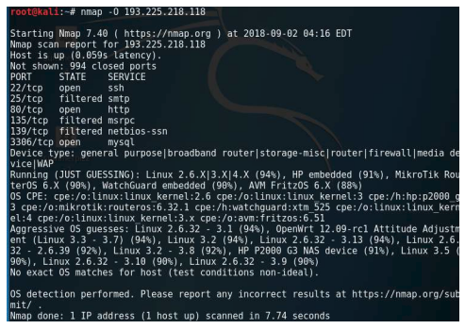

Service version detection
Version detection interrogates the ports to determine more about what is actually running. The nmap-service-probes database contains probes for querying various services and match expressions to recognize and parse responses.
Nmap tries to determine the service protocol, the version number, hostname, device, the OS family. With banner grabbing completely exact version numbers can be retrieved (Banner info can be modified).
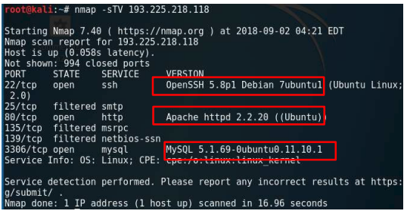

Hping2, hping3
Besides nmap there are other port scanners like the hping family.
- Firewall testing
- Advanced port scanning
- Network testing, using different protocols, TOS, fragmentation
- Manual path MTU discovery
- Advanced traceroute, under all the supported protocols
- Remote OS fingerprinting
- Remote uptime guessing
- TCP/IP stacks auditing

Examples:
Fin scan: hping3 -c 1 -V -p 80 -s 5050 -F 0daysecurity.com
Smurf attack: hping3 -1 --flood -a VICTIM_IP BROADCAST_ADDRESS
Land attack (DOS): hping3 -V -c 1000000 -d 120 -S -w 64 -p 445 -s 445 –flood
- --flood: sent packets as fast as possible. Don't show replies.
- -V <-- Verbose
- -c --count: packet count
- -d --data: data size
- -S --syn: set SYN flag
- -w --win: winsize (default 64)
- -p --destport [+][+]<port> destination port(default 0) ctrl+z inc/dec
- -s --baseport: base source port (default random)

Nmap scripting engine
Nmap is not only a port scanner, but a lightweight vulnerability discovery tool as well. With the scripting capabilities we can specify special requests using the lua language. The Nmap database contains prewritten scripts that are put into categories:
• Auth • Broadcast • Brute • Default • Discovery • DOS • Exploit • External • Fuzzer • Intrusive • Malware • Safe • Version • Vuln

Nmap scripting engine
Example: nmap –sT –p21 –script==ftp-vuln-cve2010-4221 target Script output:
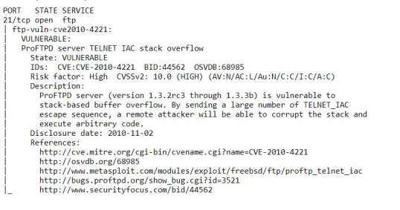
Other examples:
All scripts from a category: nmap –sT –p21 –script==vuln target
All scripts (carpet bombing!): nmap –sT –p21 –script==all target

Online port scanning (viewdns.info)
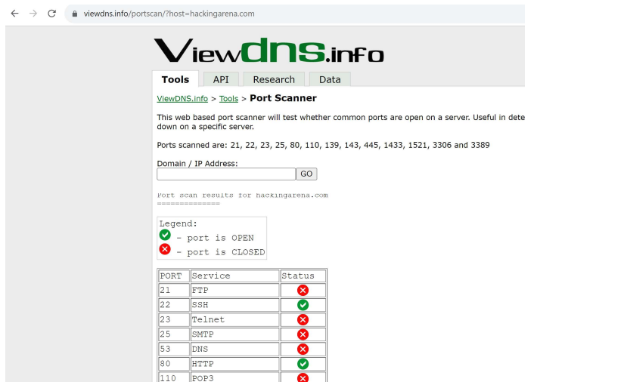
Online port scanning (censys.io)
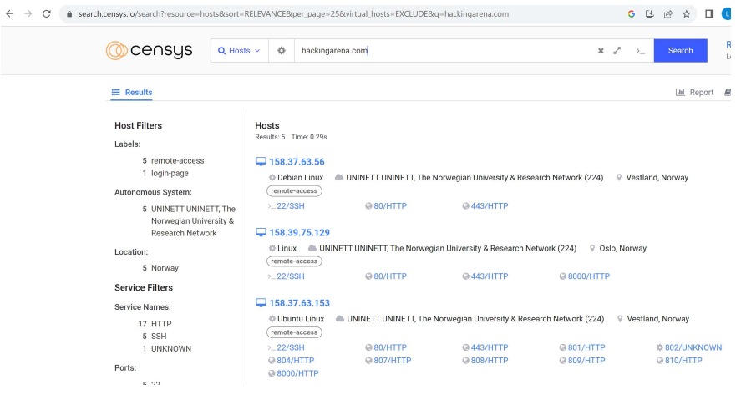
Port scanning summary: inventory
- The result of the port scanning has to be summarized in a table (Inventory)
- The inventory should be part of the final pentest report
- The table contains all the discovered hosts with all discovered services in separate rows
- Each service has a comment field if it was compromised during the pentest
- The client can evaluate each service if it should be closed or assign a responsible person for all operating services

Special port scanners: Firewalk, Zmap
Firewalk was a special internal network scanner in the beginning of the 2000s (cannot be used today). It was able to exploit of a flow of the TCP implementation and scan the internal network with one hop behind a firewall (it used customized ttl values).
Zmap is a superfast layer2 port scanner. It is able to map the whole ipv4 network range within 45 minutes for one port. (https://zmap.io/)

